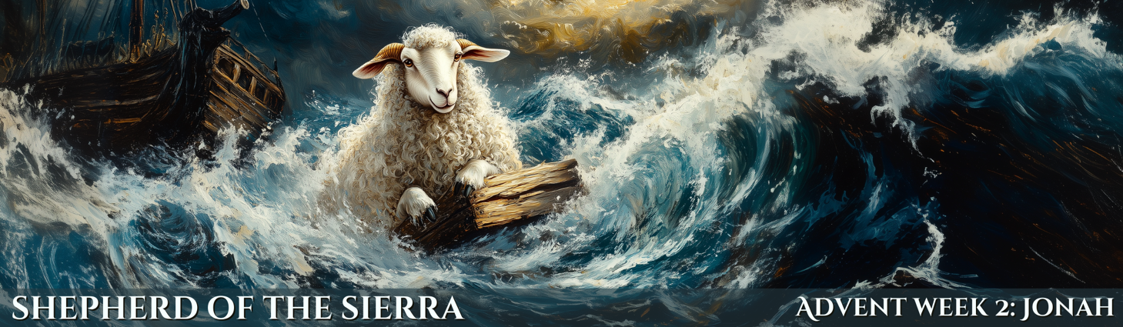

**WELCOME and INVOCATION**

**OPENING SONG: *“Savior of the Nations, Come”*** *(332)*

1 Savior of the nations, come, Virgin’s Son, make here Your home! Marvel now, O heav’n and earth, That the Lord chose such a birth.

2 Not by human flesh and blood, By the Spirit of our God, Was the Word of God made flesh— Woman’s offspring, pure and fresh.

3 Here a maid was found with child, Yet remained a virgin mild. In her womb this truth was shown: God was there upon His throne.

4 Then stepped forth the Lord of all From His pure and kingly hall; God of God, yet fully man, His heroic course began.

5 God the Father was His source, Back to God He ran His course. Into hell His road went down, Back then to His throne and crown.

6 For You are the Father’s Son Who in flesh the vict’ry won. By Your mighty pow’r make whole All our ills of flesh and soul.

7 From the manger newborn light Shines in glory through the night. Darkness there no more resides; In this light faith now abides.

8 Glory to the Father sing, Glory to the Son, our king, Glory to the Spirit be Now and through eternity.

**CONFESSION and ABSOLUTION**

P: If we say we have no sin, we deceive ourselves, and the truth is not in us.

**All:** **But if we confess our sins, God, who is faithful and just, will forgive our sins and cleanse us from all unrighteousness.**

P: Let us then confess our sins to God our Father.

**All: Most merciful God, we confess that we are by nature sinful and unclean.  We have sinned against You in thought, word, and deed, by what we have done and by what we have left undone.  We have not loved You with our whole heart; we have not loved our neighbors as ourselves.  We justly deserve Your present and eternal punishment.  For the sake of Your Son, Jesus Christ, have mercy upon us.  Forgive us, renew us, and lead us, so that we may delight in Your will and walk in Your ways to the glory of Your holy name.  Amen.**

*(Please Sit)*

***Jonah 3:1-10*** Then the word of the Lord came to Jonah the second time, saying, “Arise, go to Nineveh, that great city, and call out against it the message that I tell you.” So Jonah arose and went to Nineveh, according to the word of the Lord. Now Nineveh was an exceedingly great city, three days' journey in breadth. Jonah began to go into the city, going a day's journey. And he called out, “Yet forty days, and Nineveh shall be overthrown!” And the people of Nineveh believed God. They called for a fast and put on sackcloth, from the greatest of them to the least of them.

The word reached the king of Nineveh, and he arose from his throne, removed his robe, covered himself with sackcloth, and sat in ashes. And he issued a proclamation and published through Nineveh, “By the decree of the king and his nobles: Let neither man nor beast, herd nor flock, taste anything. Let them not feed or drink water, but let man and beast be covered with sackcloth, and let them call out mightily to God. Let everyone turn from his evil way and from the violence that is in his hands. Who knows? God may turn and relent and turn from his fierce anger, so that we may not perish.”

When God saw what they did, how they turned from their evil way, God relented of the disaster that he had said he would do to them, and he did not do it.

***Romans 10:12-15* -** For there is no distinction between Jew and Greek; for the same Lord is Lord of all, bestowing his riches on all who call on him. For “everyone who calls on the name of the Lord will be saved.” How then will they call on him in whom they have not believed? And how are they to believe in him of whom they have never heard? And how are they to hear without someone preaching? And how are they to preach unless they are sent? As it is written, “How beautiful are the feet of those who preach the good news!”

P: This is the Word of the Lord.**All: Thanks be to God.**

**CHILDREN’S MESSAGE and Gospel Reading (Luke 2:25-32)**

*Children of all Ages are encouraged to gather at the steps. Please join in singing the first verse of “Jesus Loves Me”*

**MESSAGE**  Pastor James

**SONG OF RESPONSE “*From Depths of Woe I Cry to Thee”*** *607*  
1 From depths of woe I cry to Thee, In trial and tribulation; Bend down Thy gracious ear to me, Lord, hear my supplication. If Thou rememb’rest ev’ry sin, Who then could heaven ever win Or stand before Thy presence?

2 Thy love and grace alone avail To blot out my transgression; The best and holiest deeds must fail To break sin’s dread oppression. Before Thee none can boasting stand, But all must fear Thy strict demand And live alone by mercy.

3 Therefore my hope is in the Lord And not in mine own merit; It rests upon His faithful Word To them of contrite spirit That He is merciful and just; This is my comfort and my trust. His help I wait with patience.

4 And though it tarry through the night And till the morning waken, My heart shall never doubt His might Nor count itself forsaken. O Israel, trust in God your Lord. Born of the Spirit and the Word, Now wait for His appearing.

5 Though great our sins, yet greater still Is God’s abundant favor; His hand of mercy never will Abandon us, nor waver. Our shepherd good and true is He, Who will at last His Israel free From all their sin and sorrow.

**APOSTLE’S CREED** *(Please Stand)*

All: I believe in God, the Father Almighty, maker of heaven and earth.

And in Jesus Christ, His only Son, our Lord, who was conceived by the Holy Spirit, born of the virgin Mary, suffered under Pontius Pilate, was crucified, died and was buried. He descended into hell. The third day He rose again from the dead. He ascended into heaven and sits at the right hand of God the Father Almighty. From thence He will come to judge the living and the dead.

   I believe in the Holy Spirit, the holy Christian Church, the communion of saints, the forgiveness of sins, the resurrection of the body, and life everlasting. Amen.

**GATHERING OF OUR OFFERINGS**

**HYMN OF DEDICATION     “Let the Vineyards Be Fruitful”** *(955)*

Let the vineyards be fruitful, Lord,  And fill to the brim our cup of blessing.

Gather a harvest from the seeds that were sown,  That we may be fed with the bread of life.  Gather the hopes and the dreams of all;  Unite them with the prayers we offer now.  Grace our table with Your presence, and give us a foretaste of the feast to come.

**PRAYERS OF THE CHURCH**

**THE LORD’S PRAYER**

Our Father Who art in heaven, Hallowed be Thy name. Thy Kingdom come. Thy will be done on earth as it is in heaven. Give us this day our daily bread. And forgive us our trespasses, as we forgive those who trespass against us. And lead us not into temptation. But deliver us from evil. For Thine is the kingdom and the power and the glory forever and ever. Amen.

**THE LORD’S SUPPER**

**Distribution of the Elements**   *(Please Sit)*

*Small children and those not instructed in this meal are invited to come forward with arms crossed for a blessing. If you're sensitive to alcohol, please take from the light-colored cups in the middle. Gluten-free wafers are in the circular container.*

**Distribution Hymns**

*"Come, Thou Long-Expected Jesus" – 338*

*"My Hope Is Built on Nothing Less" – 575*

*"What Is This Bread" - 629*

**Communion Dismissal and Benediction**  *(Please Stand)*

**CLOSING SONG: “*The Common Doxology”***

Praise God, from whom all blessings flow;

Praise Him, all creatures here below;

Praise Him above, ye heav’nly host:

Praise Father, Son, and Holy Ghost. AMEN!